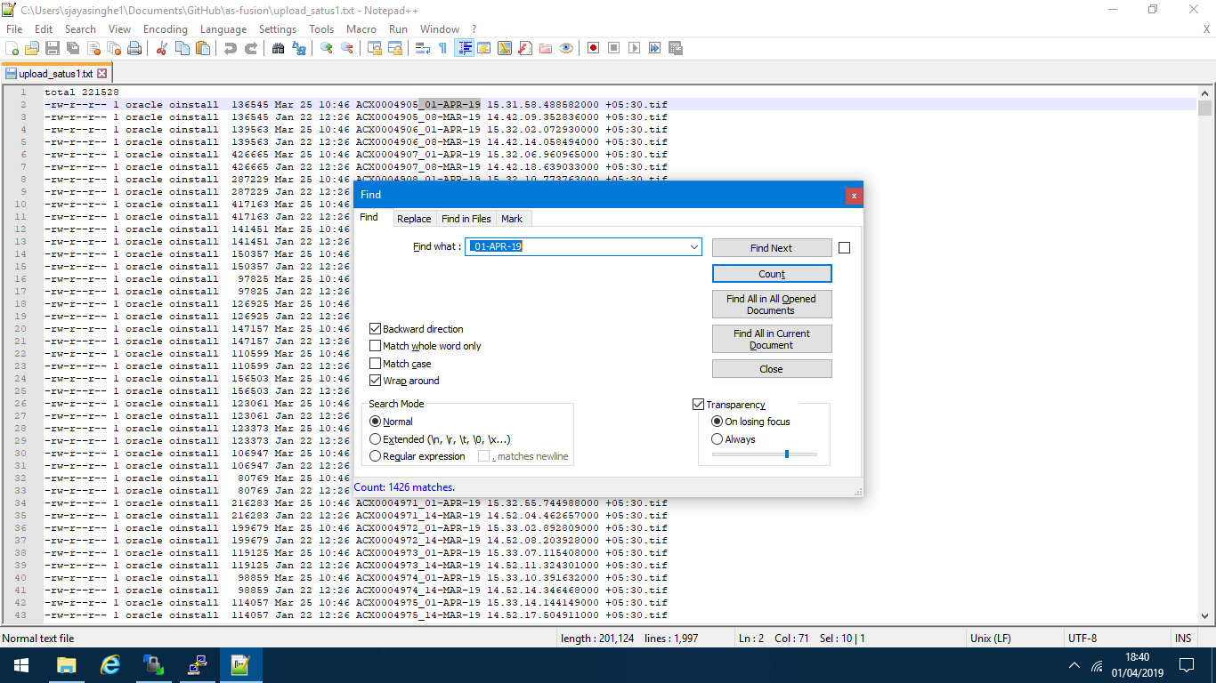

Uploaded 1426 images as of 18:42 01/04/201918:42 01/04/201

exec XX_ERP_INV_ATTACH_PKG.XX_EXECUTE;

***execute 1***

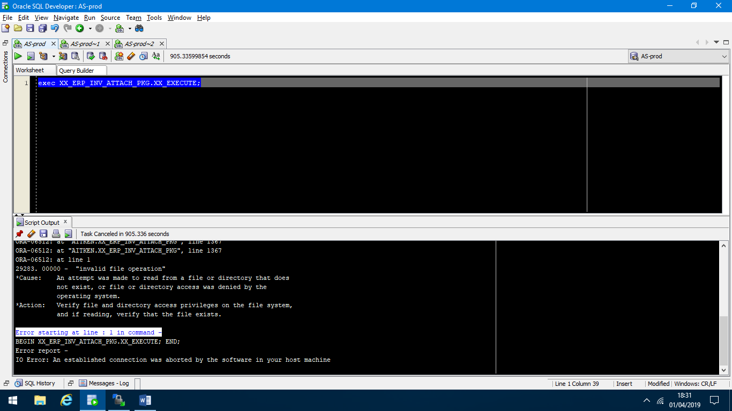

***execute 2***

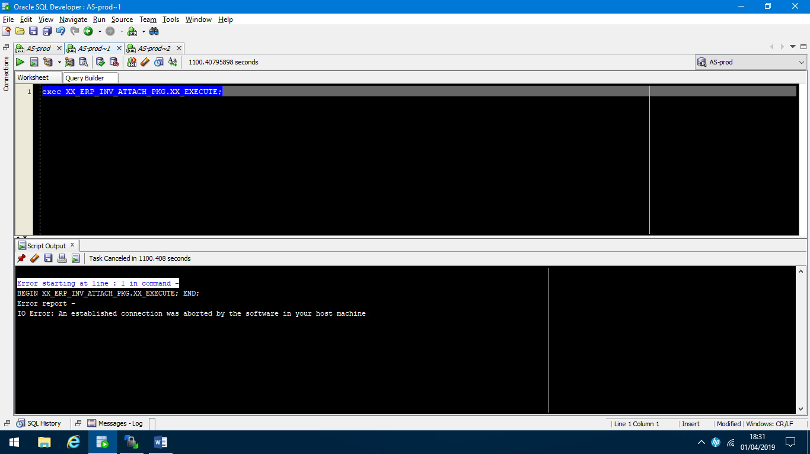

***execute 3***

